Course: COSC457.101 – Database Management Systems

Instructor: Leon Bernard

Room: YR-304

February 27, 2020 7:00 pm

**Database Model**

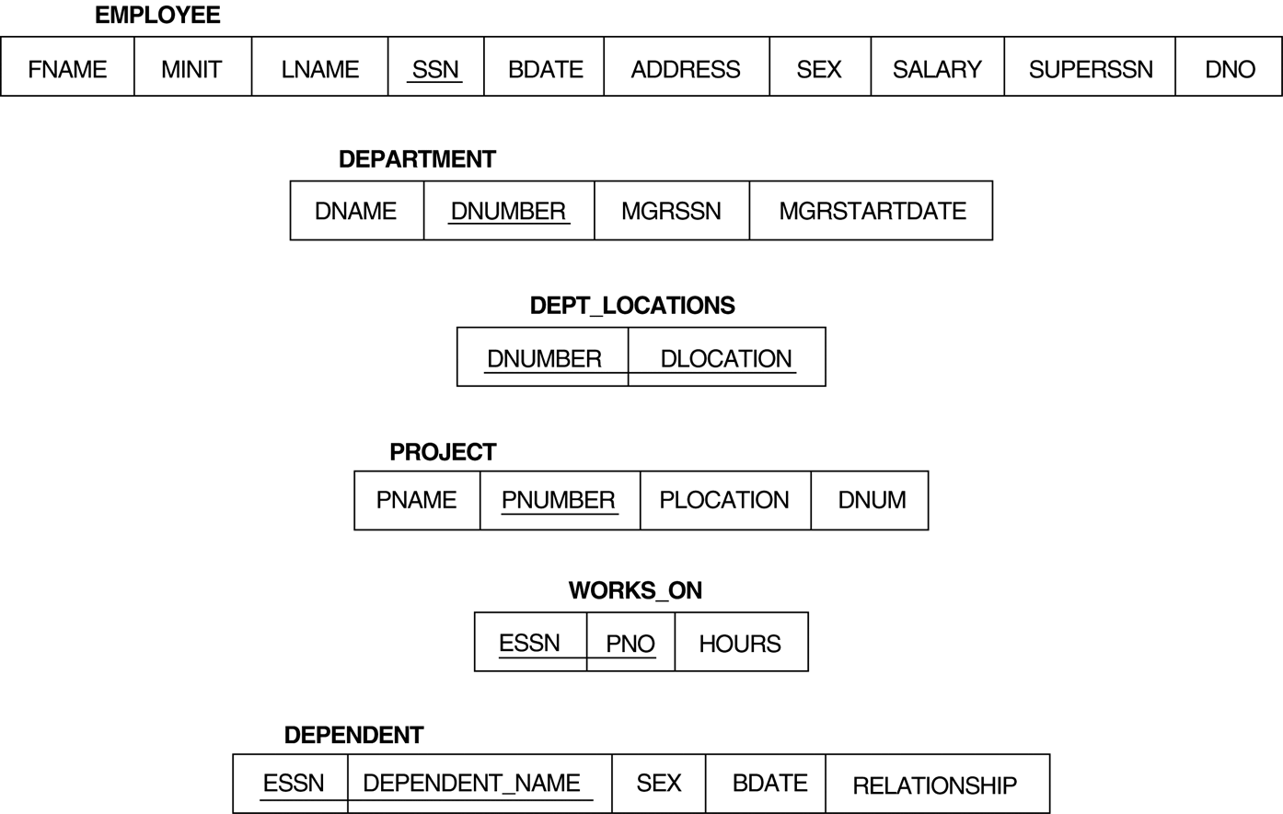

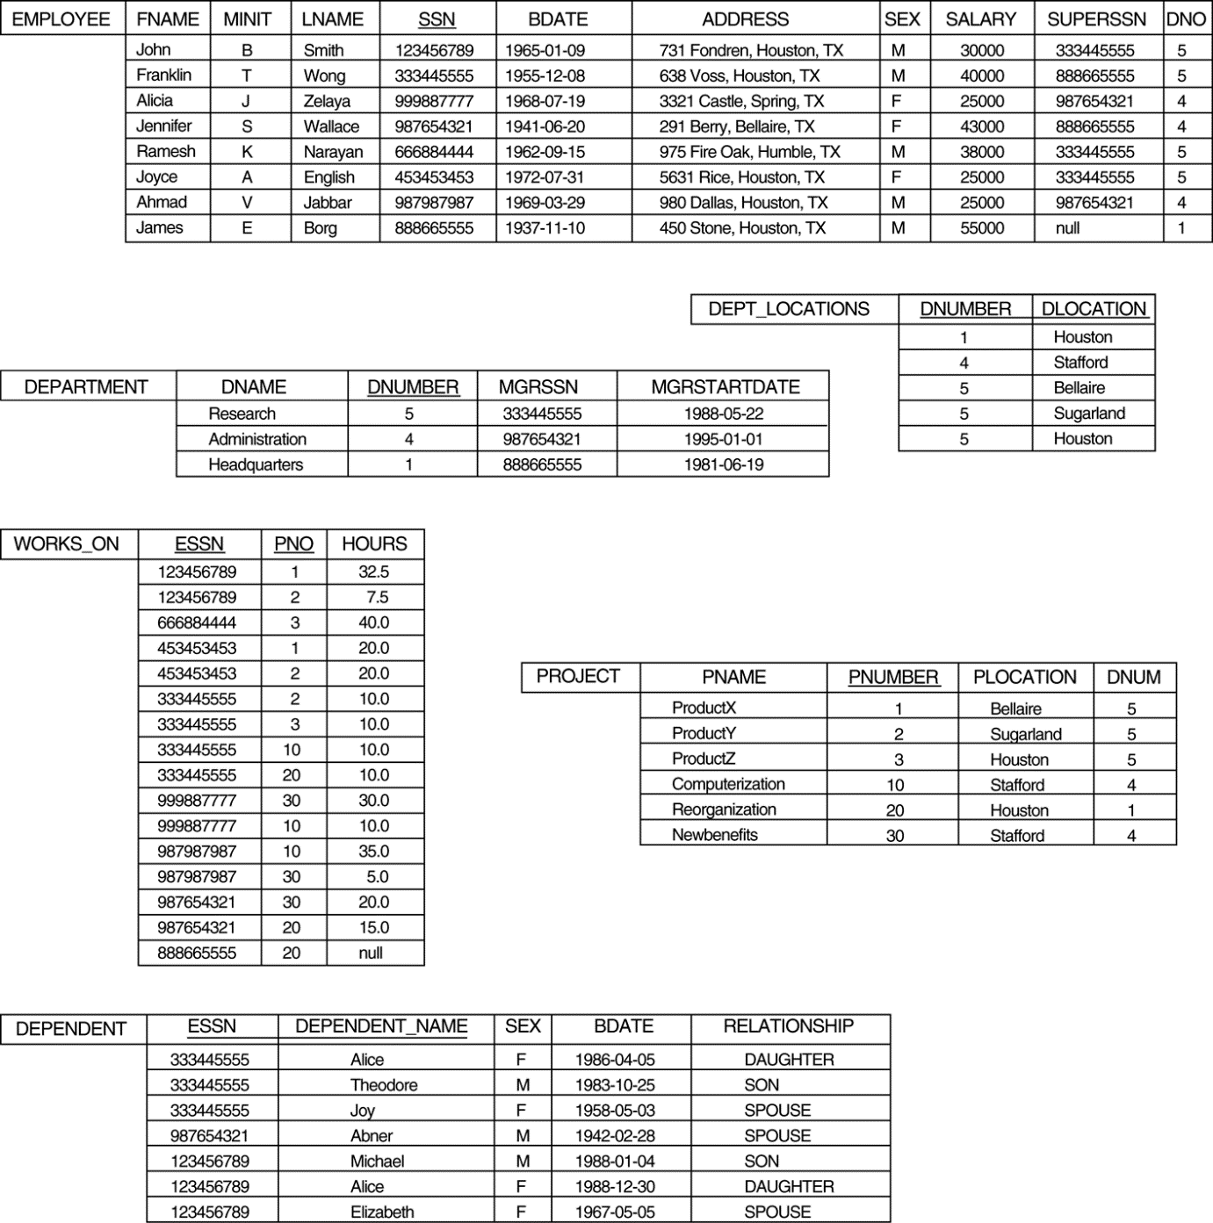

**SQL statements**

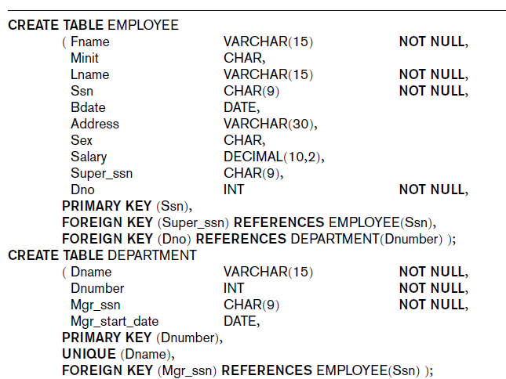

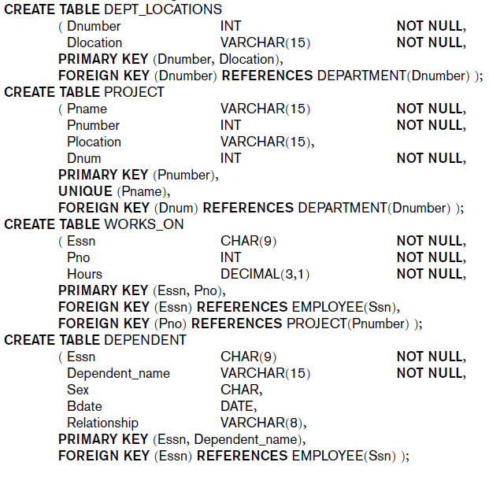

**Questions**

1. Retrieve the list of employees who worked for department 5.

select Fname,Lname from EMPLOYEE  
where Dno = 5;

1. Retrieve the list of employees without dependents.

Select Fname, Lname

From EMPLOYEE

INNER JOIN DEPENDENT

ON EMPLOYEE.Ssn=DEPENDENT.Essn where DEPENDENT_NAME=’NULL’;

1. Retrieve the maximum salary of male employees.

Select max(Salary) from EMPLOYEE where Sex = M;

1. Retrieve the average salary of female employees.

Select avg(Salary) from EMPLOYEE where Sex = F;

1. Increase female employees’ salary by 10% then rerun the query from Question 4.

Update EMPLOYEE

Set salary = salary * 1.1

Where Sex = F;

1. Retrieve the total number of hours work by each employee per department controlling the project.
2. Add columns TotalHours and NumOfEmployee to Project table

Alter table PROJECT

Add TotalHours INT

Add NumOfEmployee INT;

1. Create a view on Employee table which only display first name, last name and department umber

Create view CustomView As

Select FNAME, LNAME, DNO

From EMPLOYEE;

1. Create the following functions
   1. A function which return the number of employees who worked on a specific project. The function input parameter is pnumber (integer)

Create function fnumOfEmployees(pnumber as int)

Returns int

As

Begin

Return (select count(*) from WORKS_ON w INNER JOIN PROJECT p

Where w.PNO = p.PNUMBER

End

* 1. A function which return the sum of hours worked on a specific project. The function input parameter is pnumber (integer)

Create function fnumOfHours(pnumber as int)

Returns int

As

Begin

Return (select count(HOURS) from WORKS_ON w INNER JOIN PROJECT p

Where w.PNO = p.PNUMBER

End

1. Create a procedure which computes the average number of hours worked on each project for a department. The procedure input parameter should be department number

Create procedure avgHoursWorked @dnumber int

as

select avg(HOURS) from WORKS_ON w INNER JOIN PROJECT p INNER JOIN DEPARTMENT d

where @dnumber = d.DNUMBER and d.DNUMBER = p.DNUM and p.PNUMBER = w.PNO

Go;

1. Create an trigger on WORKS_ON table which updates Project’s TotalHours and NumOfEmployee columns using the functions from previous question

Create trigger updateHours

Before INSERT

On PROJECT

For each row

Set TotalHours = fnumOfHours(PNUMBER);

Create trigger updateNumEmp

Before INSERT

On PROJECT

For each row

Set NumOfEmployee = fnumOfEmployees(PNUMBER);